00c - Sprint Plan - Sprint 2

Part 1: Sprint Info & Task Management board

Team number: 12
Sprint Number: 2 | Sprint Duration (Start – End Dates): May 11 - May 15
Task Manager Platform Link here (Clickable and Public) :
https://trello.com/invite/b/69f1252414c3094e343d62fe/ATTI08c02146cbf06f985e835fed3d7d8b55340072F9/-
Task Coordinator name here :
Jonah Botelho

Part 2: Sprint Plan

Sprint Goal(s)

Add support for all languages and create report generation to complete all MVP requirements.

Outcomes
Outcome | Answer to “So What?”
40 different languages will be supported | So almost all our users can use the app without struggle
AI generated report will be created | So users can get the normalized in depth report to view or share with their employer
Test plan will be reviewed or expanded | So we can better test our application after making changes

Deliverables

Deliverables | Show me
All 40 translation files | Source code/project folder
Example AI generated report | Example PDF

Tasks
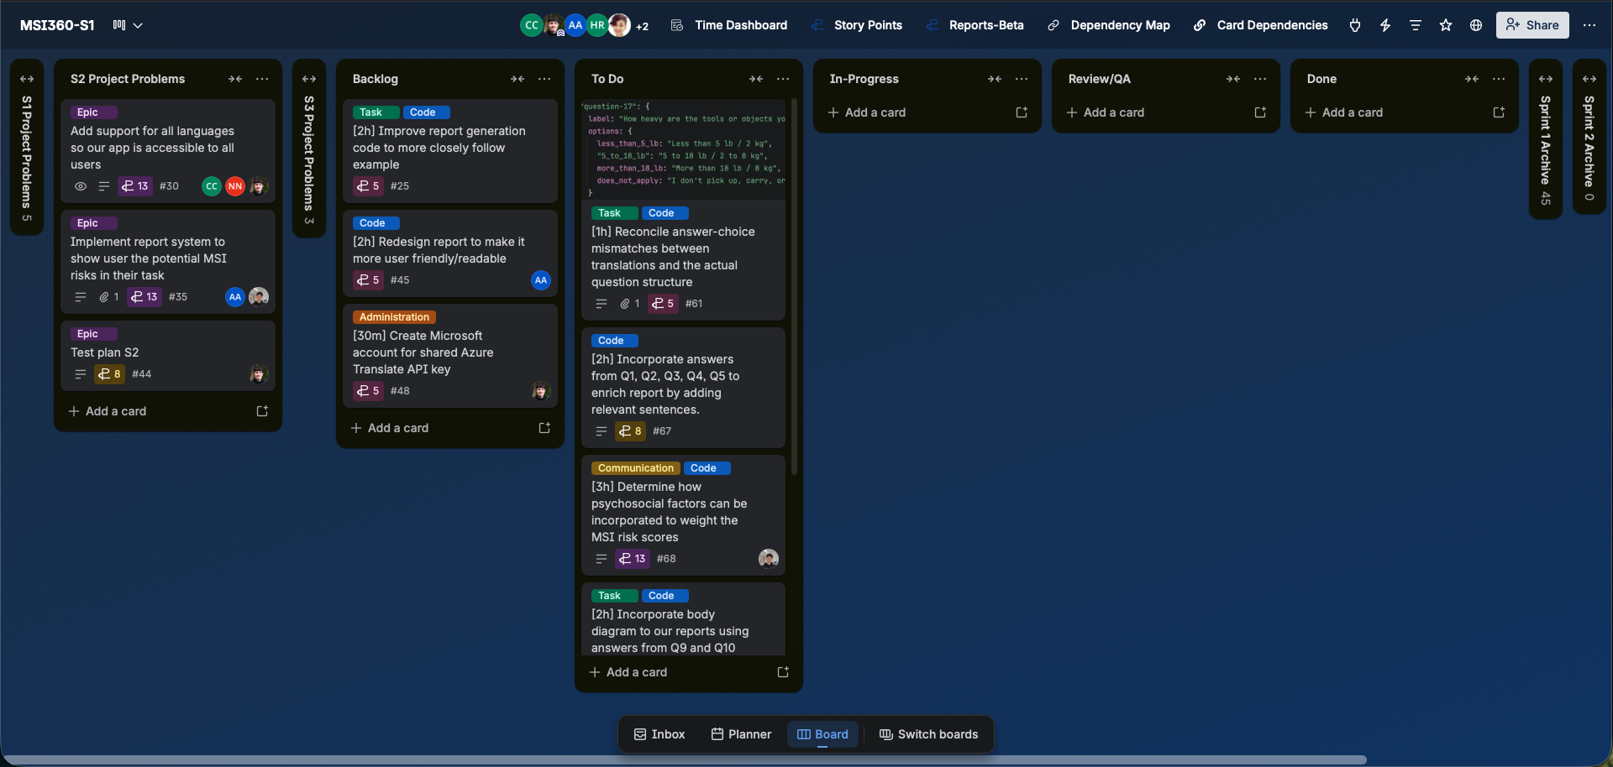

Risks and Issues
Risk ID + Related Task ID(s) | Risk or Issue Description | Potential Impact | Mitigation/Resolution Steps | Status
#71 | Add translated question text files for all languages | We will be translating questions into various languages that we do not understand ourselves. | For any language that we do understand, manually verify that it is correct. | Open
#72 | Add translated text for static app text | We will be translating questions into various languages that we do not understand ourselves. | For any language that we do understand, manually verify that it is correct. | Open
#73 | Add system to automatically translate user input into English to send to LLM | We will be translating questions into various languages that we do not understand ourselves. | For any language that we do understand, manually verify that it is correct. | Open

